**[EE54301] Computer Vision**

**Final Project**

**(FriendsPseudoNet)**

ID: 20195213

Name: 이현수 (Hyeonsoo Lee)

1. **Algorithm Description**

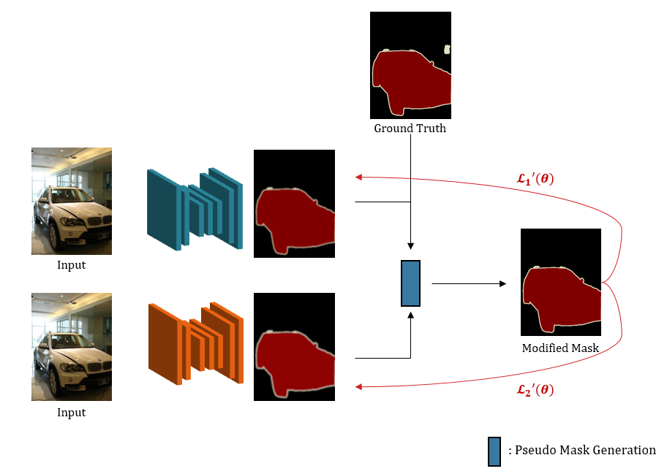

In Pascal VOC dataset, there is class 255 which is boundary and un-labeled pixel. This 255 class is ignored when loss is calculated. I want to make use of these pixels in class 255.

For that purpose, each model predicts from an image. From those predictions and ground truth, I can calculate the modified mask.

To modify ground truth, the confidence of predictions is needed. If two models predict that pixel as a same class, then I can let set that unlabel as that same class. And then, I calculate the confidence by averaging probabilities. Then, I can set a certain threshold for generating modified mask. This threshold can be calculated by Eq.1. And then we can modify the ground truth mask by Eq.2. Equations in detail are attached below. 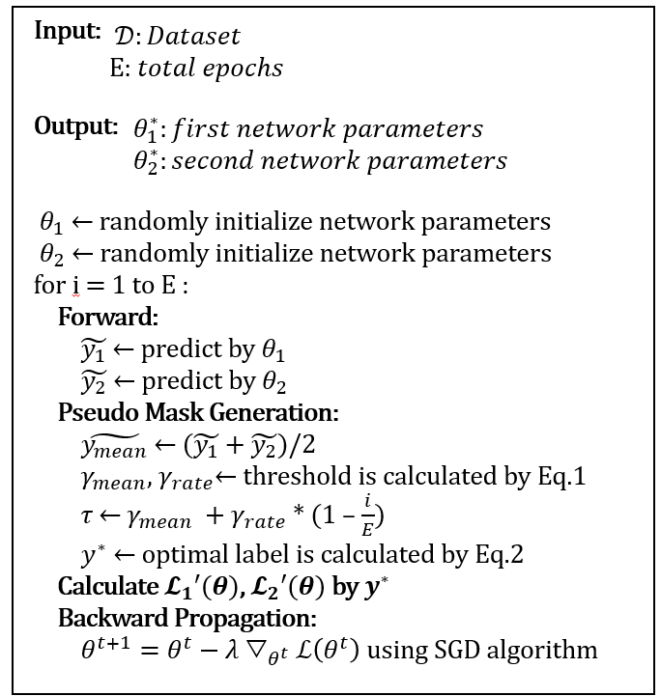

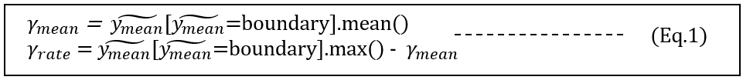

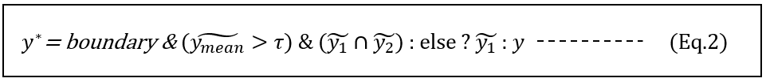

1. **Implementation Scope**

I implemented the whole training procedure for two models. But especially, the main thing is correcting labels.

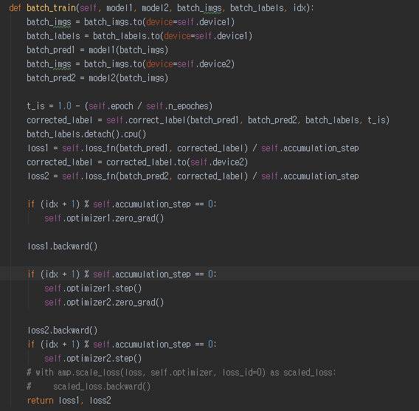

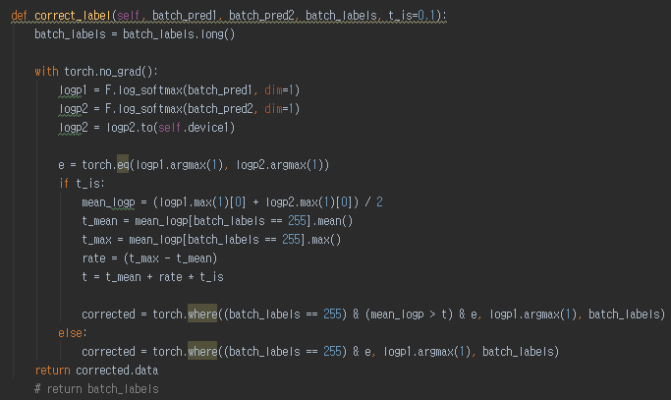

There are two predictions are generated by two models. Based on these two predictions, this right above function corrects a label.

1. **Experimental Results**

Before have an experiment, I want to prove this generated mask is reasonable or not. I pretrained two models (model 1: DeepLab-v3+ with resnet101, model 2: DeepLab-v3+ with drn54)

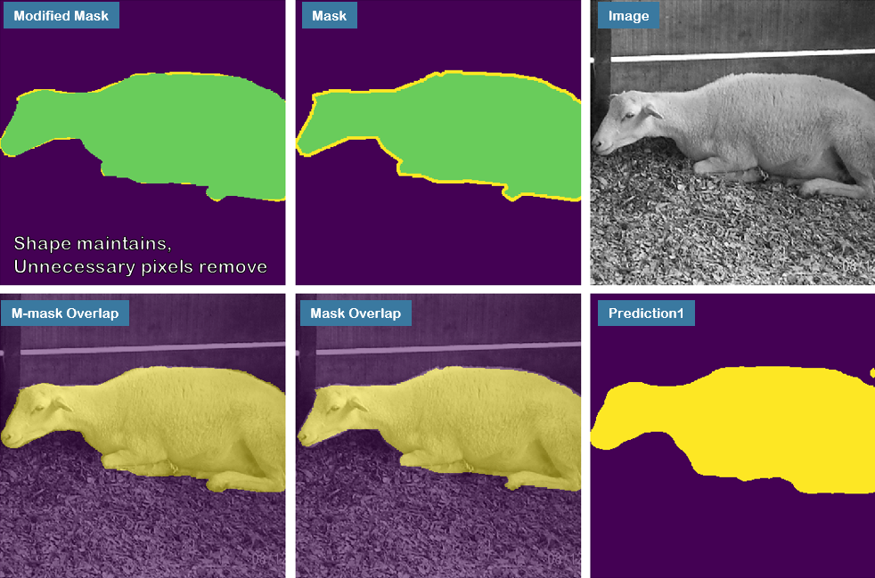

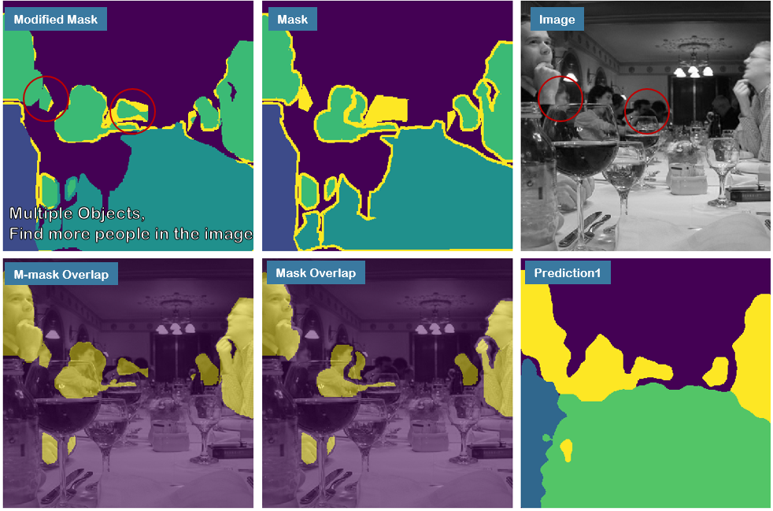 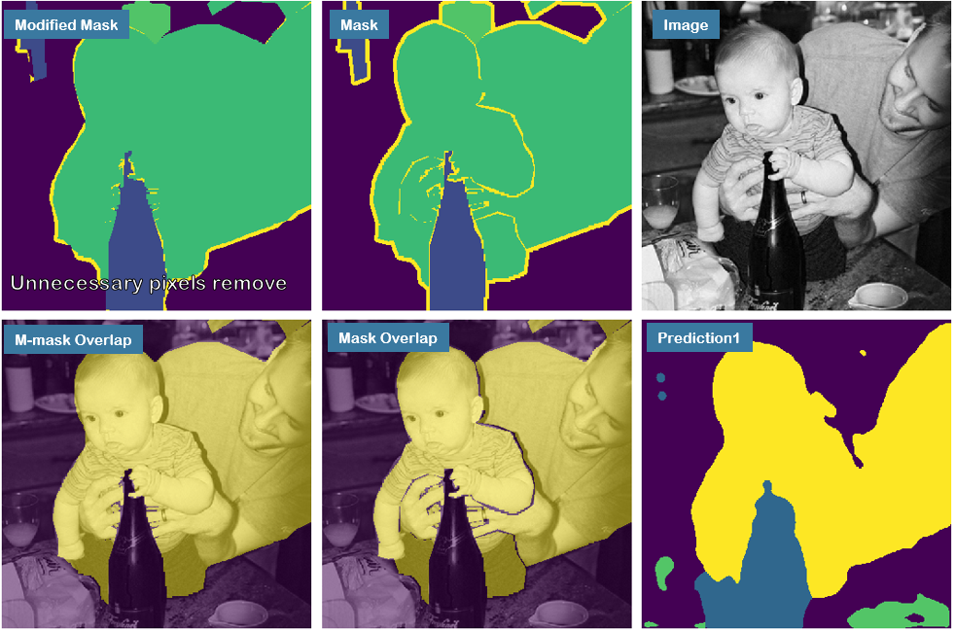

From these results, I can say generated mask can be benefitial.

Base models are selected as the same models (DeepLab-v3+ with resnet101 backbone). The reason why I selected two models is two local minima have different results even if the model type is same. But I think I failed on implementing for training two models simultaneosly. Both of using corrected labels or using original labels, the results are not good. It only achieves about 0.5 MIoU even the single trained model is 0.7279

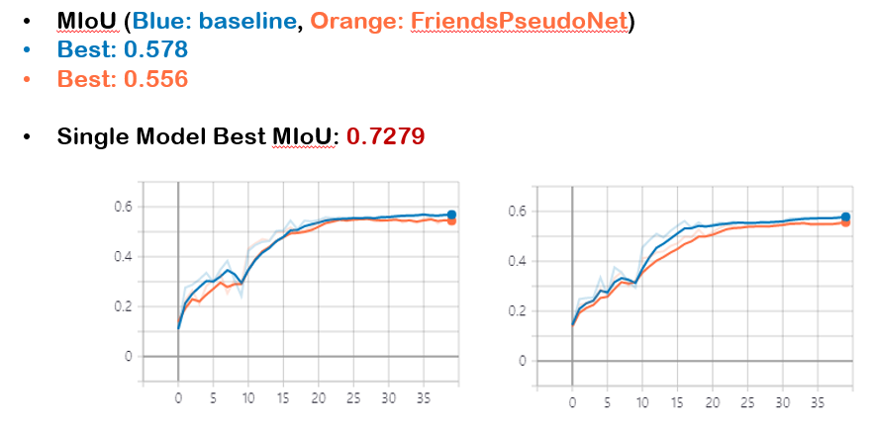

Thus, I decided to modify model a little bit by removing a friend. (PseudoNet)

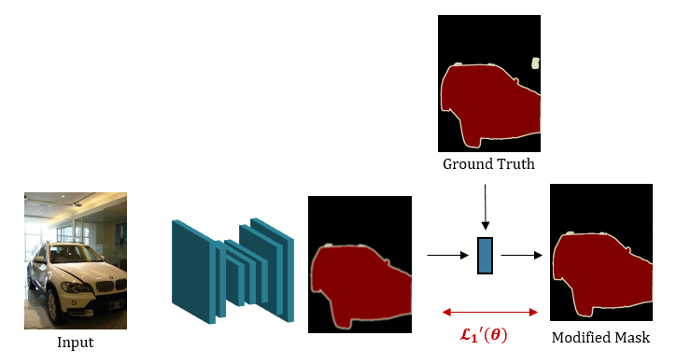

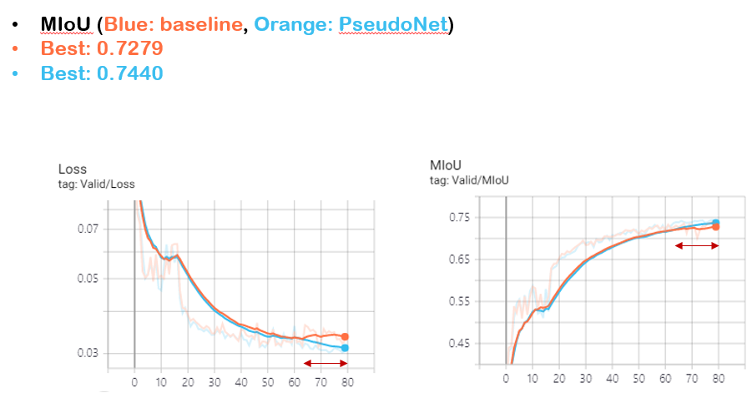

Then, PseudoNet have the better result than the baseline.

1. **Discussion**

In conclusion, I propose self-generating mask algorithm which helps the segmentation task. This algorithm makes people’s annotation cost by setting unlabeled pixels.

In future work, it can be extensible to different dataset by making ambiguous pixels of un-labeled or, we can generate un-labeled class during training stage. Moreover, It can be extensible to any task such as classification, detection and so on.